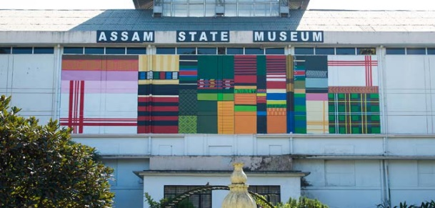
NORTH-EAST TOUR PACKAGE
GUWAHATI-SHILLONG-KAZIRANGA-TAWANG (10NIGHTS-11DAYS)
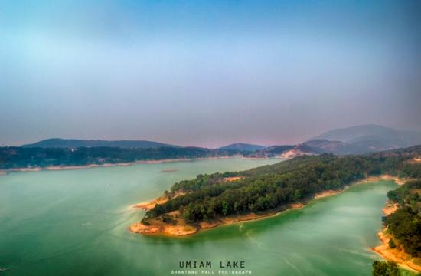

Day 1: Meet our representative at Guwahati Railway station/Airport after arriving in the morning and drive for the full day city tour- State museum, Science museum, Srimanta Sankardev kalakhetra, Balaji temple, Nabagraha Temple, Digholi pukhuri, Assam state zoo. Check in hotel and overnight stay.
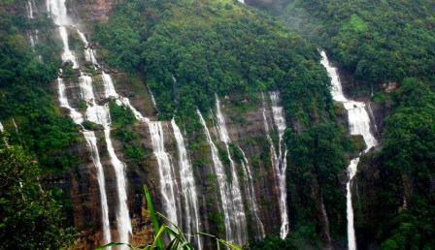
Day 2: After breakfast transfer to Shillong en-route enjoy the view of Umiam Lake (Barapani)- the biggest manmade lake in North-East. Check in Hotel. After refreshment enjoy the half day city tour – Wards lake, Cathedral Catholic Church, Shillong peak, Elephant falls, Lady Hydari Park, Latium canyon. Overnight stay at hotel.
Day 3: After breakfast transfer to Cherrapunjee-the wettest place on the earth. Enjoy the full day trip visiting Seven sister falls, Nohkalikai Falls, Masmai cave, Limestone cave, Thankarang park, Double decker root bridge. Back to Shillong and night stay at hotel.

Day 4: After breakfast Check out hotel and transfer to Kaziranga. Check in hotel and take rest. In the evening enjoy your free time relaxing in the calm and serene atmosphere. Overnight stay at hotel.
Day 5: In the early morning after breakfast enjoy an elephant safari / a jeep safari at Central range (Kohora) / Western range (Bagori) of Kaziranga National Park. Major attractions are One horned rhino ceros, Indian elephant, Swamp deer, Water buffalo, Hoolock gibbon, Royal Bengal tiger, various species of birds and mammals. Overnight Stay at hotel.
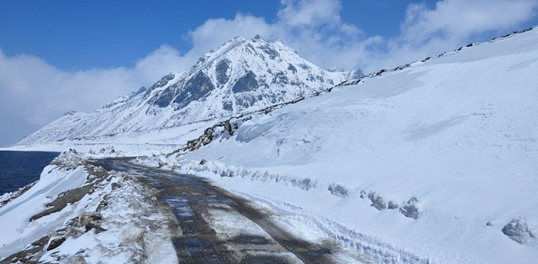
Day 6: Check out hotel. Drive to Bomdila and visit Bomdila monastery. Check in hotel and overnight stay.
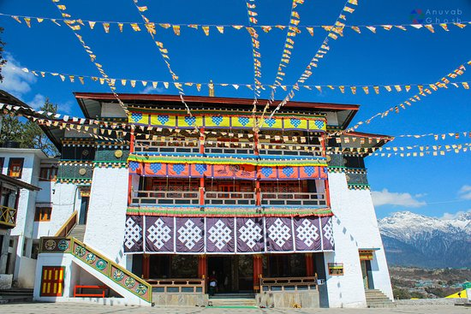
Day 7: After breakfast transfer to Tawang. En-route visit the Sela Pass-the 2nd highest motor able road in the world besides Sela lake and Jaswant Garh war memorial. Check in hotel and overnight stay.
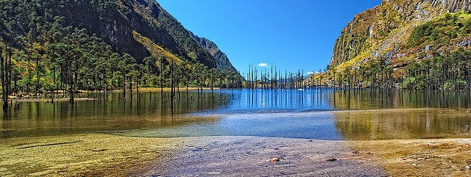
Day 8: After breakfast enjoy the full day city tour- Tawang Monastery which is 400 years old, P.T Tso Lake, Tawang War Memorial Lake, Urgelling Gompa (Six Dalai Lama’s birth place), local market, craft centre. At evening enjoy the light & sound show at War Memorial. Back to hotel and night stay.
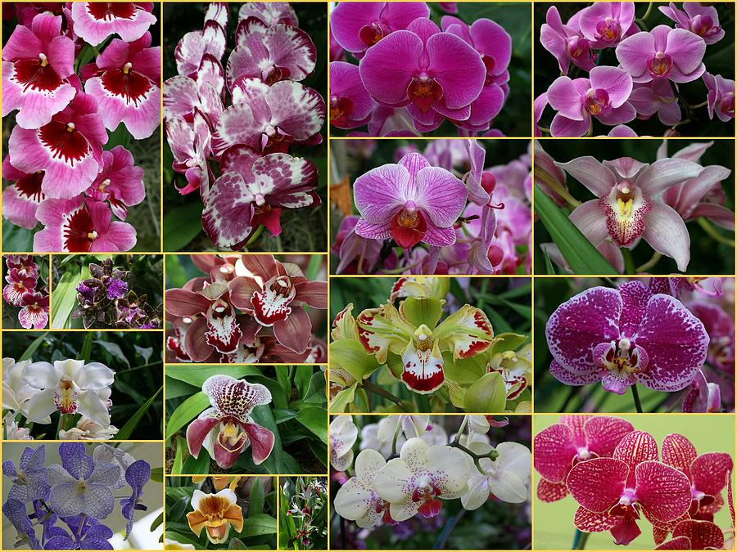
Day 9: After breakfast check out hotel and drive to Dirang en-route visit the Nuranang falls at Jang. Check in hotel and overnight stay.
Day 10: Check out hotel and transfer to Bhalukpung en-route visiting Tipi Orchid garden. Check in hotel and night stay.
Day 11: Check out hotel early in the morning and transfer to Guwahati railway station/airport for the final journey.

